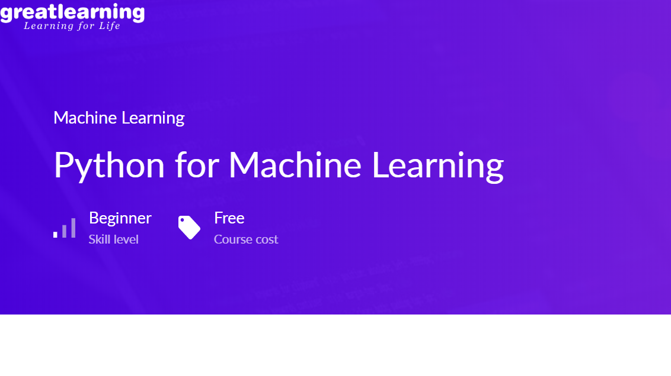

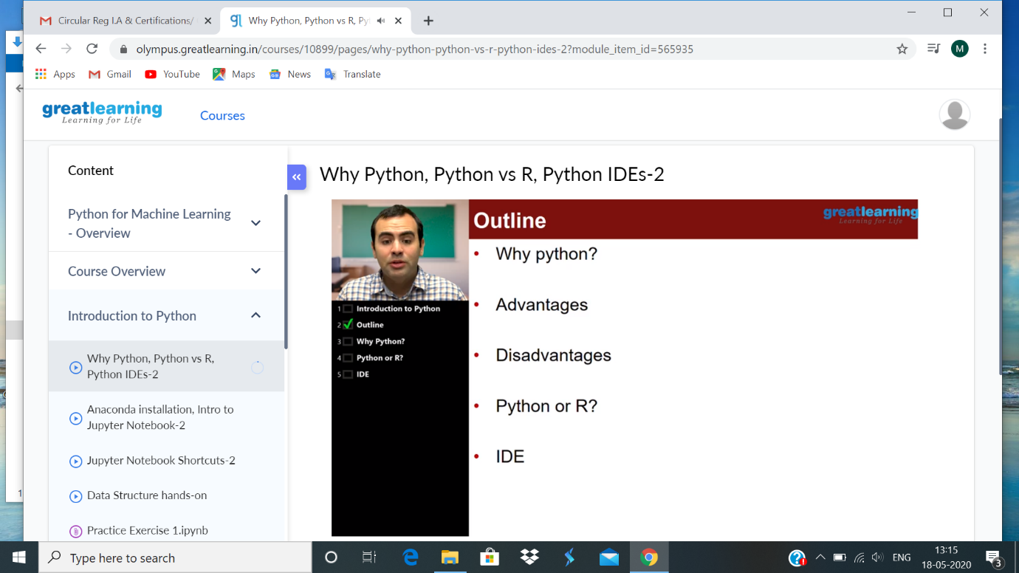

PYTHON FOR MACHINE LEARNING:

In todays class learnt why python is used, what are the advantages, disadvantages, python or R, IDE.Python is easy to implement. Development time is quick, easy to implement, debugging is straight forward, python is a open source. There are many popular IDE’s: pycharm, jupyter note books and spiders. It is possible to use python without IDE. Commun ication of ideas is easy in jupyter. Pyhton is not restricted to data science. Python is an open source.